1.1.1 Area of Circle
Algorithm
1. Start
2. Input radius r
3. Set π = 3.14
4. area = π × r × r
5. Display area
6. Stop
Flowchart :-
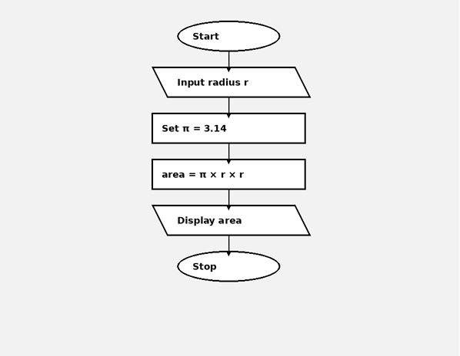
Program :-
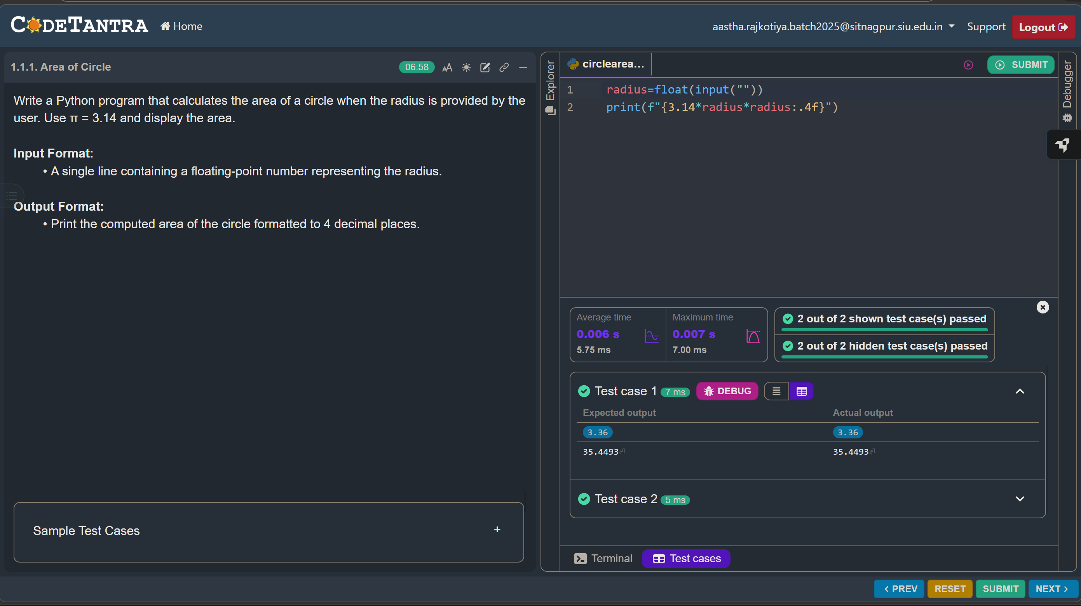

1.1.2 Area of Rectangle
Algorithm
1. Start
2. Input length
3. Input width
4. area = length × width
5. Display area
6. Stop
Flowchart : -
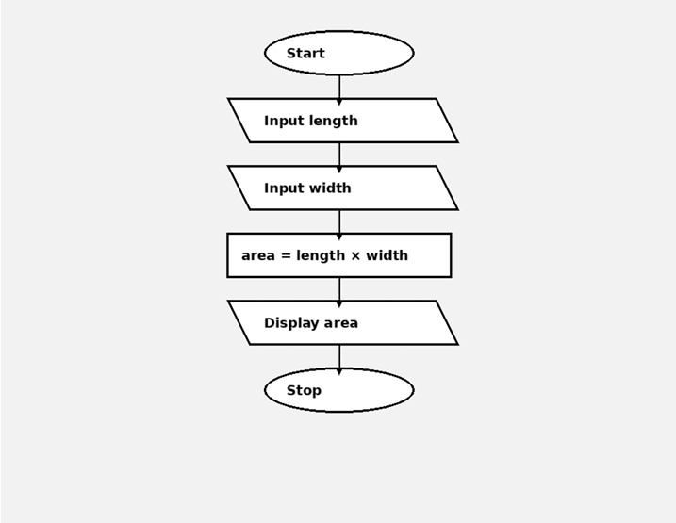
Program : -
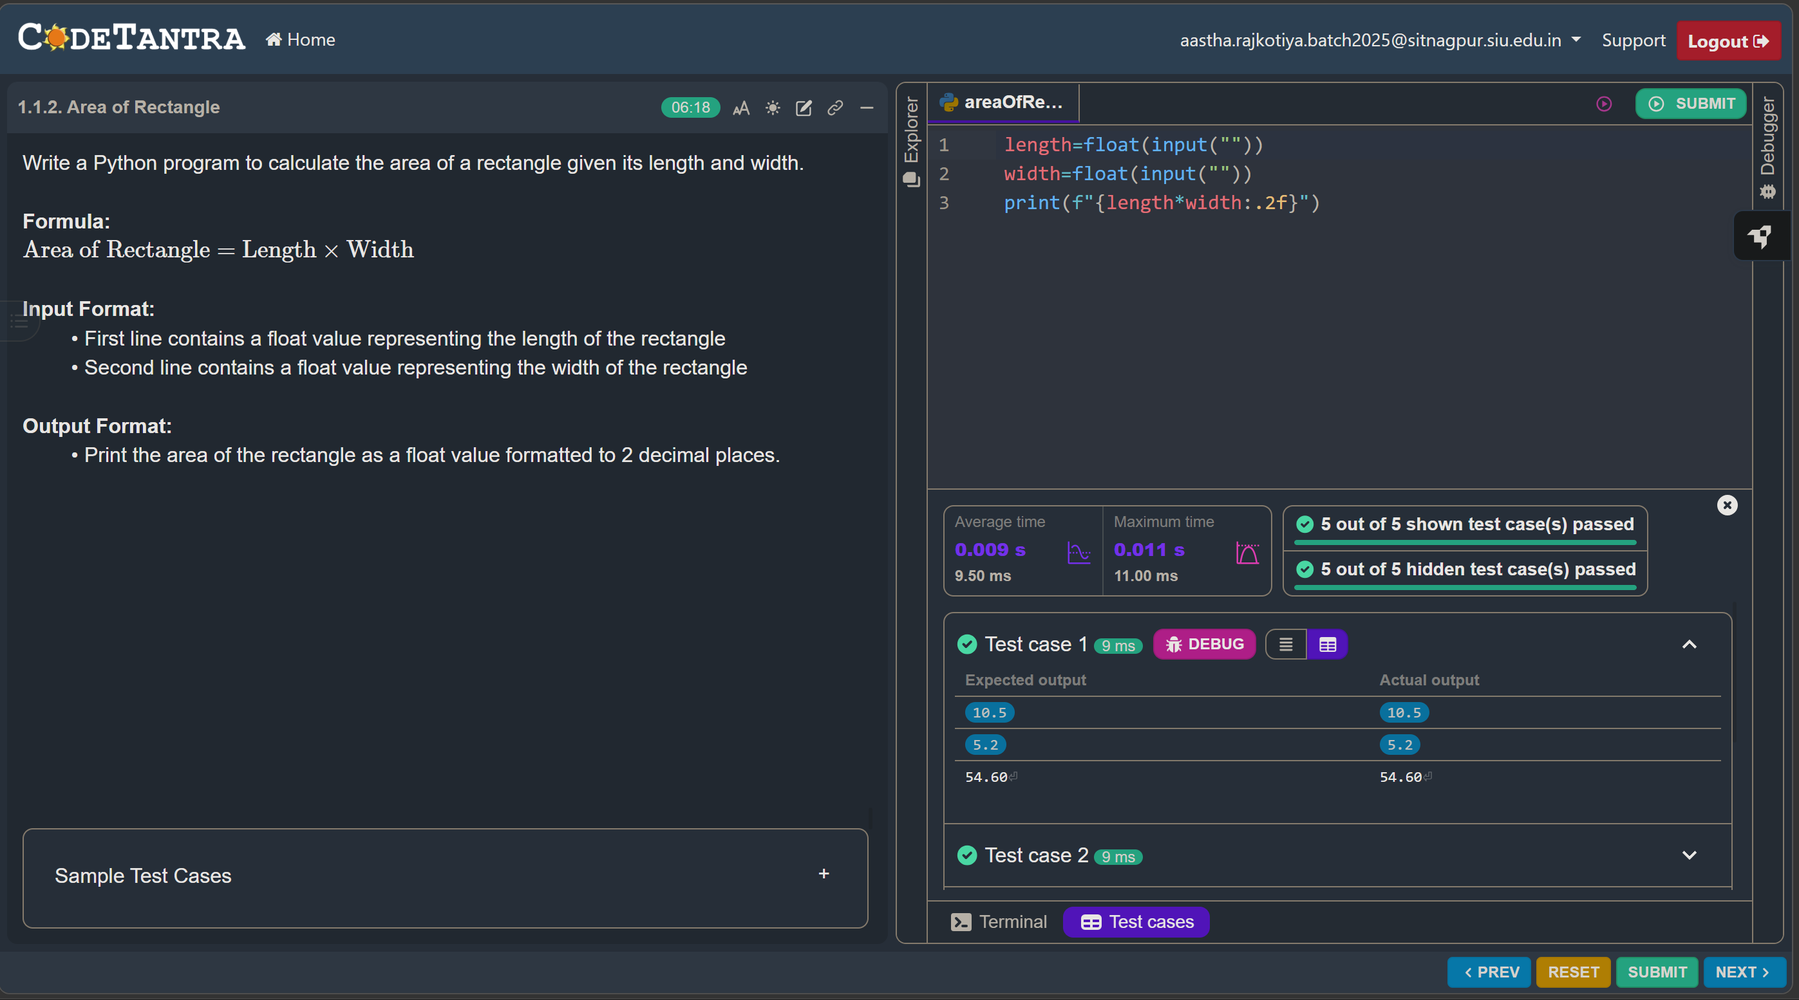
1.1.3 Calculate Area of Square
Algorithm
1. Start
2. Input side length
3. area = side × side
4. Display area
5. Stop
Flowchart :-
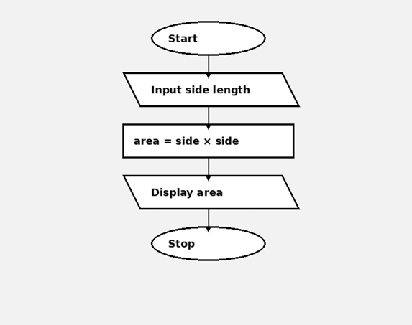
Program :-
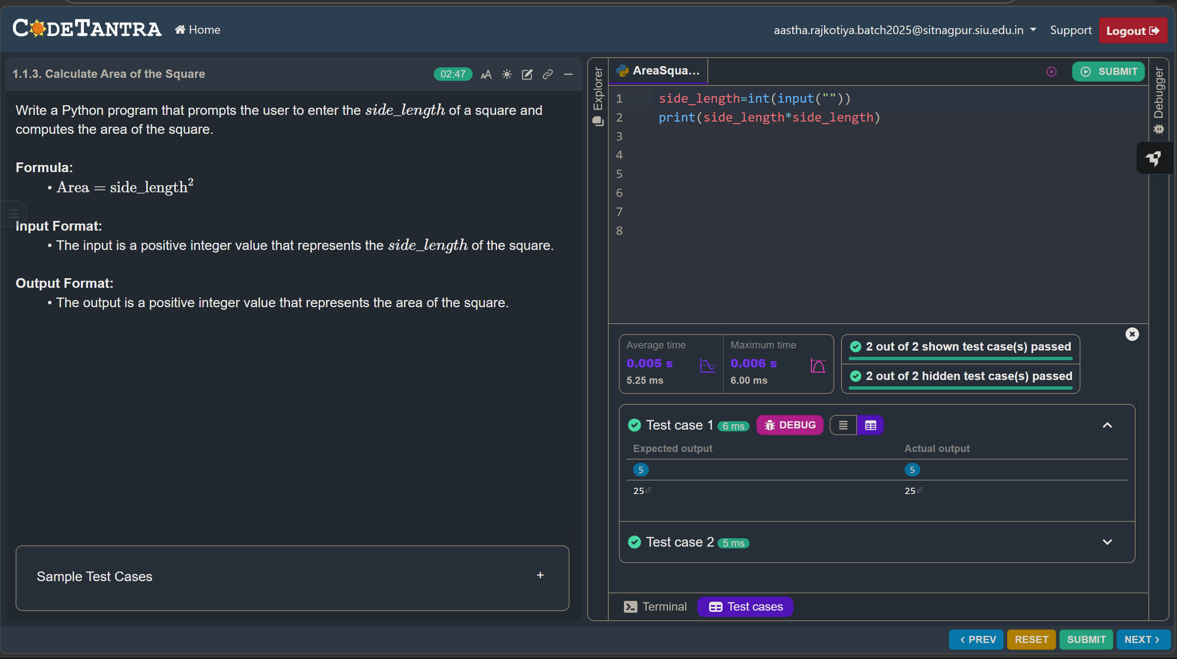
1.1.4 Area of Triangle
Algorithm
1. Start
2. Input base
3. Input height
4. area = 0.5 × base × height
5. Display area
6.Stop
Flowchart :-
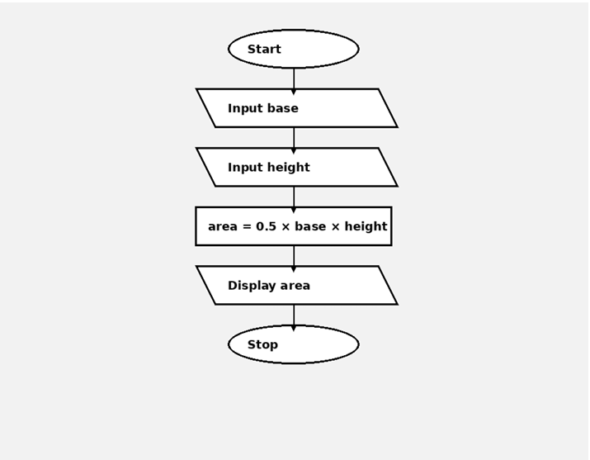
Program :-
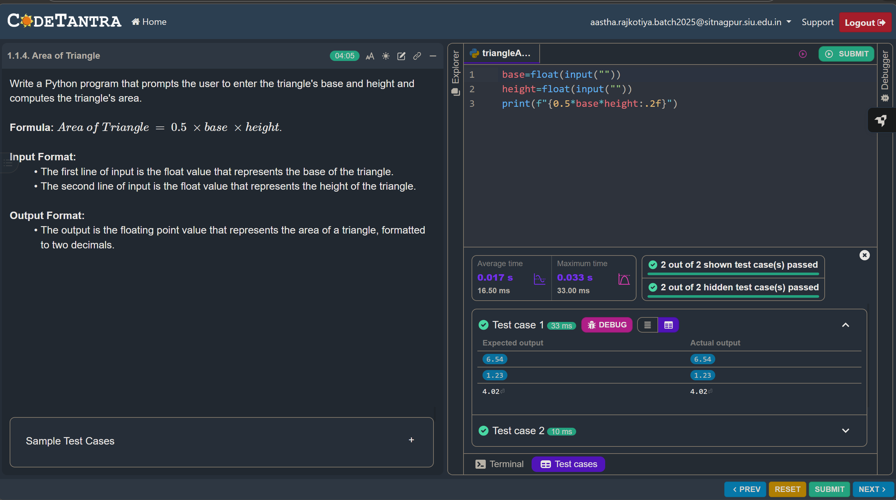
1.1.5 Student Pass or Fail Status
Algorithm
1. Start
2. Input marks
3. marks ≥ 40 ?
4. Display Pass / Fail
5. Stop
Flowchart :-
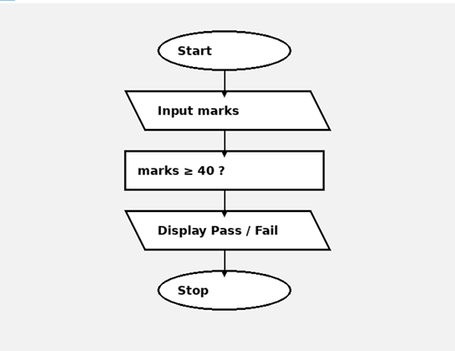
Program :-
